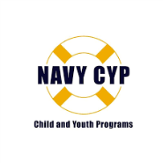
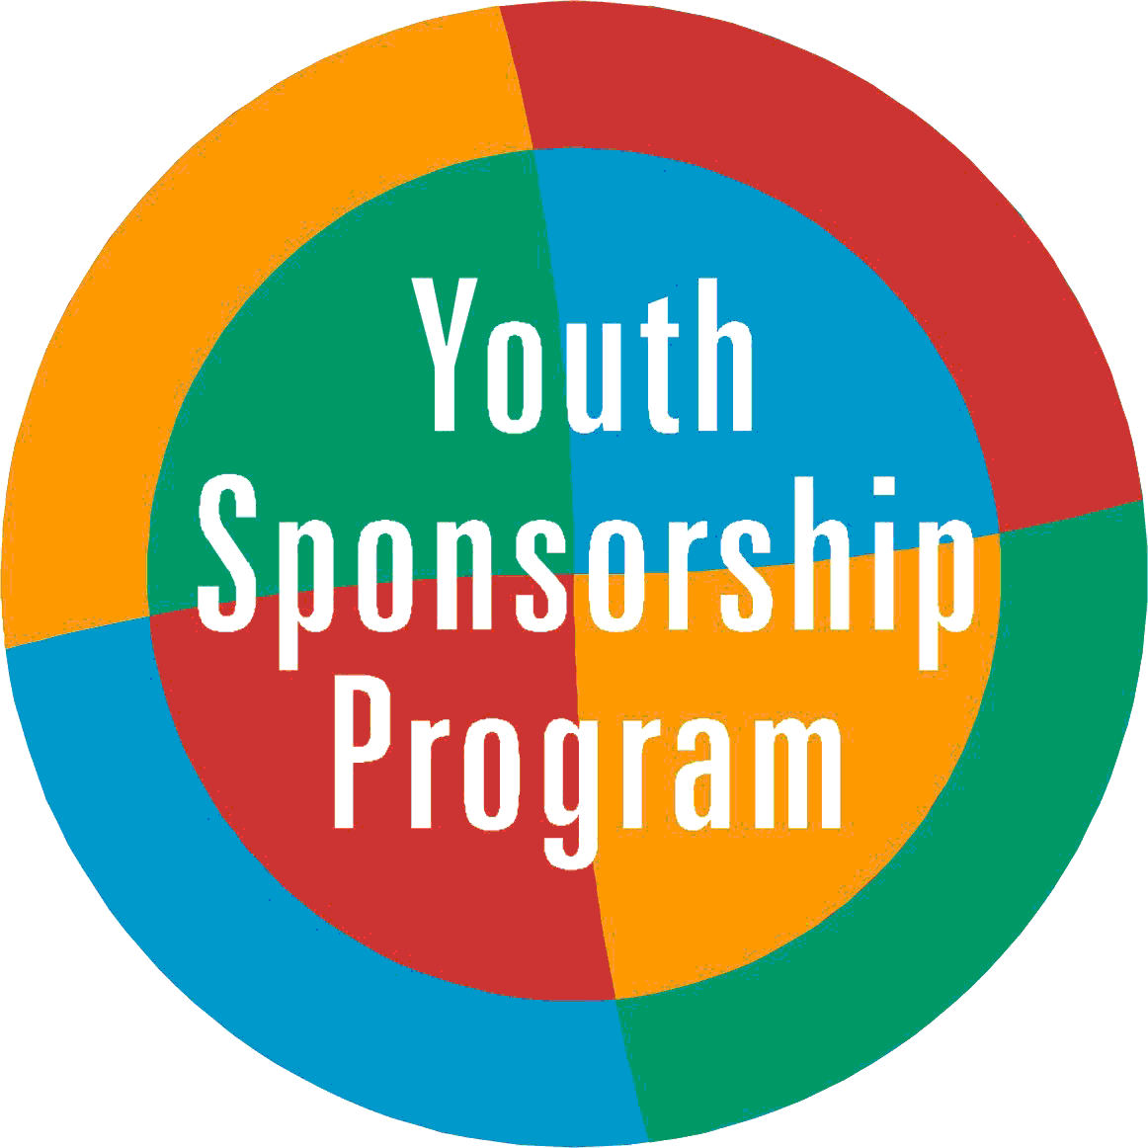
Norfolk Naval Shipyard Youth Sponsorship Program
Application (New Student)

Date _____________________
Name of Applicant ______________________________________ ( ) Male ( ) Female
Birth date ______________________ Grade _______________
Address ______________________________________________________________
Home Telephone/Cell Number _______________________________
Email Address _________________________________________________________
Where did you move from? __________________________________
Where else have you lived? __________________________________
Are you interested in signing up for the youth sponsorship program? Yes _____ No _____
If yes, please fill out information below and email to SLO.NNSY.fct@navy.mil

Hobbies and Interests ________________________________________________________________________________________________________________________________________________________

Sports, Music, Club/Programs I am currently involved in are
________________________________________________________________________________________________________________________________________________________
In my free time, I like to
________________________________________________________________________________________________________________________________________________________
What I like most about my last school was
________________________________________________________________________________________________________________________________________________________
What are you most concerned about with your move to this school and this area?
________________________________________________________________________________________________________________________________________________________

Signature ________________________________________ Date _____________

